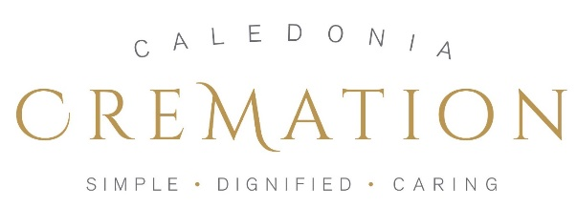

REGISTER OF WISHES REGARDING THE FUNERAL OF:

NAME: _______________________________________________________________

ADDRESS: _______________________________________________________________

________________________________________________________________

________________________________________________________________

This document is intended to provide those planning my funeral with some guidelines to work with. My hope is that it will minimise any distress, confusion or disagreement about what I would like and how much to spend.
This is not a legal document.
I hereby declare, being of sound mind, that the following choices reflect my wishes beyond my death.

- I would like to be directly cremated and have no service at the crematorium.
My preference would be to use Caledonia Cremation for this aspect of my funeral process.
Caledonia Cremation is part of Caledonia Funeral Aid CIC – a social enterprise managed by Community Renewal Trust (SC566867 registered Orkney Street, G51 2BX)

In the event that Caledonia Funeral Aid is no longer trading, I would ask those organising my funeral to seek out other funeral directors who offer direct cremation.

- I would like any memorial service organised by family and friends to be held: (Please strike out those that do not apply)

- in this specific venue/area: ________________________________

- in an area where there is: ___________________________________

- at a venue decided upon my family and friends

- other: _________________________________________________________

- I would like the service to be conducted by: (please specify a name if you have someone in mind)

- my local minister_________________________________________________

- a humanist or civil celebrant ___________________________________________

- other: __________________________________________________________

- I would like the service to:

- have a theme of _______________________________________________

- be informal and fun

- be a celebration of my life

- other – please specify any wishes eg: attendees to wear bright colours, bring a red flower etc , (attach an extra page if necessary, signed)

- Any service could include the following songs, hymns, poems, readings:
(again feel free to attach a list separately and sign it)

_____________________________________________________

_____________________________________________________

______________________________________________________

- I would like my ashes to be:

- collected by a family member or friend and scattered in

_____________________________________ at an appropriate point

- collected by family or friends and scattered in a place of their choosing

- Placed in the garden of remembrance of the crematorium in which I am cremated.

- other:
________________________________________________________________

- My direct cremation will be funded by:

- savings

- my estate

- next of kin/family

- insurance policy no: _________________________________________________

held with__________________________________________________________

- other: ____________________________________________________________

- I also wish that: (please specify here any other wishes not addressed above or attach and sign any further outline of your wishes eg: regarding monies spent or any other detail that feels important to you)

_____________________________________________________________________

_____________________________________________________________________
- A copy of this document has also been placed with:

NAME:

ADDRESS:___________________________________________________________

_____________________________________________________________________

who is my: (lawyer, executor, family member – please specify) _________________________

I confirm that the above pages and any attachments reflect my wishes beyond my death and that they are a useful guide for those planning my cremation and any separate memorial service.

SIGNED: _____________________________________________________________________

DATE: ____________________________________________________________________

We would appreciate you also answering the following question for research purposes.
I choose direct cremation for (place a tick next to those that apply)
- Philosophical reasons
- Economic reasons
- Other: (please give details)

Please keep a copy of this document with your important papers and, also give a copy to your next of kin or solicitor. We also recommend you send a signed copy to us for safe keeping at the address below.

Caledonia Cremation, Pennywell Resource Centre, 31 Pennywell Road, EDINBURGH EH4 4PJ

OPTIONAL DONATION
Our Register of Wishes service is free, however we would like to suggest an optional donation of £25 which will help us to help us to cover our costs.

If you are able to donate, please use one of the following methods and put ‘ROW’ followed by your surname in the reference so that we may match the payment up.

- By debit card online https://www.nowdonate.com/checkout/vm534e32259bap7vheh6
- By cheque to “Caledonia Funeral Aid CIC” posted to the address above.
- By bank transfer using details below.

Account number: 00636754
Sort Code: 83-21-16
Bank: Royal Bank of Scotland PLC
Account name Caledonia Funeral Aid CIC

Please note the donation is entirely optional and there is no pressure to make this payment.

THANK YOU

