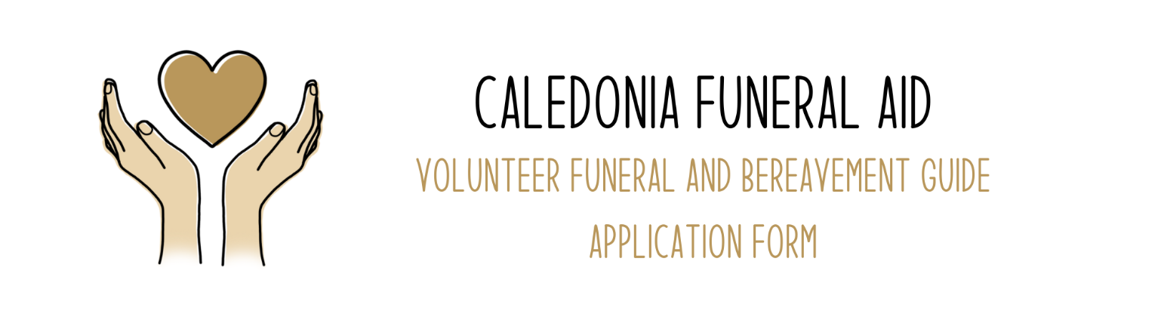

Applicant Information
Full Name: |  |  |  |  |  | Date:

Address:

Please state city, town or village where you live

Phone: |  | Email

How many hours per week would you want to volunteer for most weeks? (We would prefer people who can commit to over 4 hours most weeks for at least the next year)

Personal Statement

Briefly describe why you would like to become a funeral and bereavement guide. If you have any experience, paid or otherwise, that you think would be applicable, then please do tell us about it here. Continue on a separate page, if necessary.
You can write as few as 100 words or as many as 1000 words. Please note that we will prioritize applicants with one or more of: 1) experience supporting people in need compassionately; 2) ability with support to arrange/host small community events (e.g. death cafes); 3) some abilities around marketing or administration.

Disclaimer and Signature
If you would like to be added to Caledonia Funeral Aid’s mailing list, then tick this box

I certify that my answers are true and complete to the best of my knowledge. If you are successful, you agree that we will need to verify your identity and convictions through Disclosure Scotland.
Signature:

Date:
Please email completed form to caledonia@funerals.scot. If you do not have access to email, then please post application to Caledonia Funeral Aid, Community Renewal Pennywell, 31 Pennywell Rd, Edinburgh, EH4 4PJ

